# INTRODUCTION

* 1. Overview

This Project helps you to maintain and manage the school related problems which further can be modified based on the requirements.

* 1. Purpose

The school management system facilitates transparent and faster communication between the authorities and the involved persons of a school.

1. **Problem Definition & Design Thinking**
   1. Empathy Map

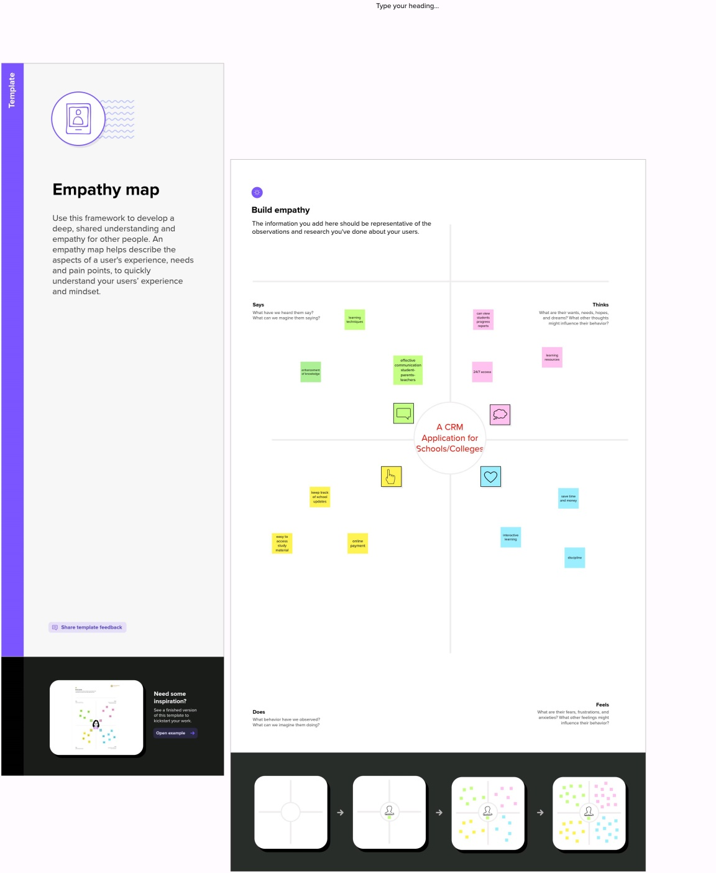

* 1. Ideation & Brainstorming Map

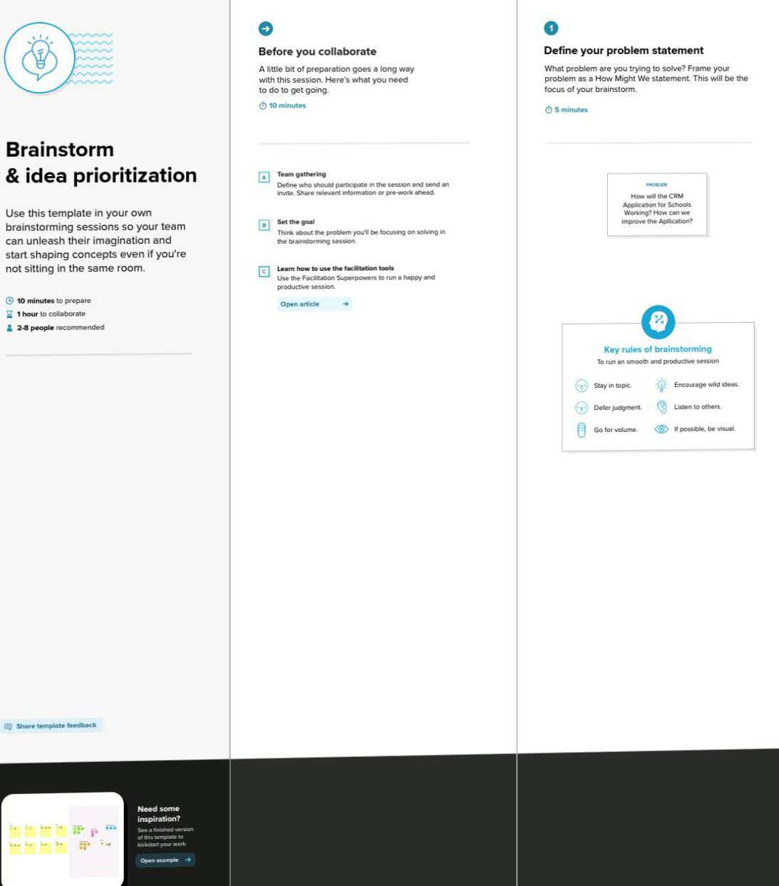

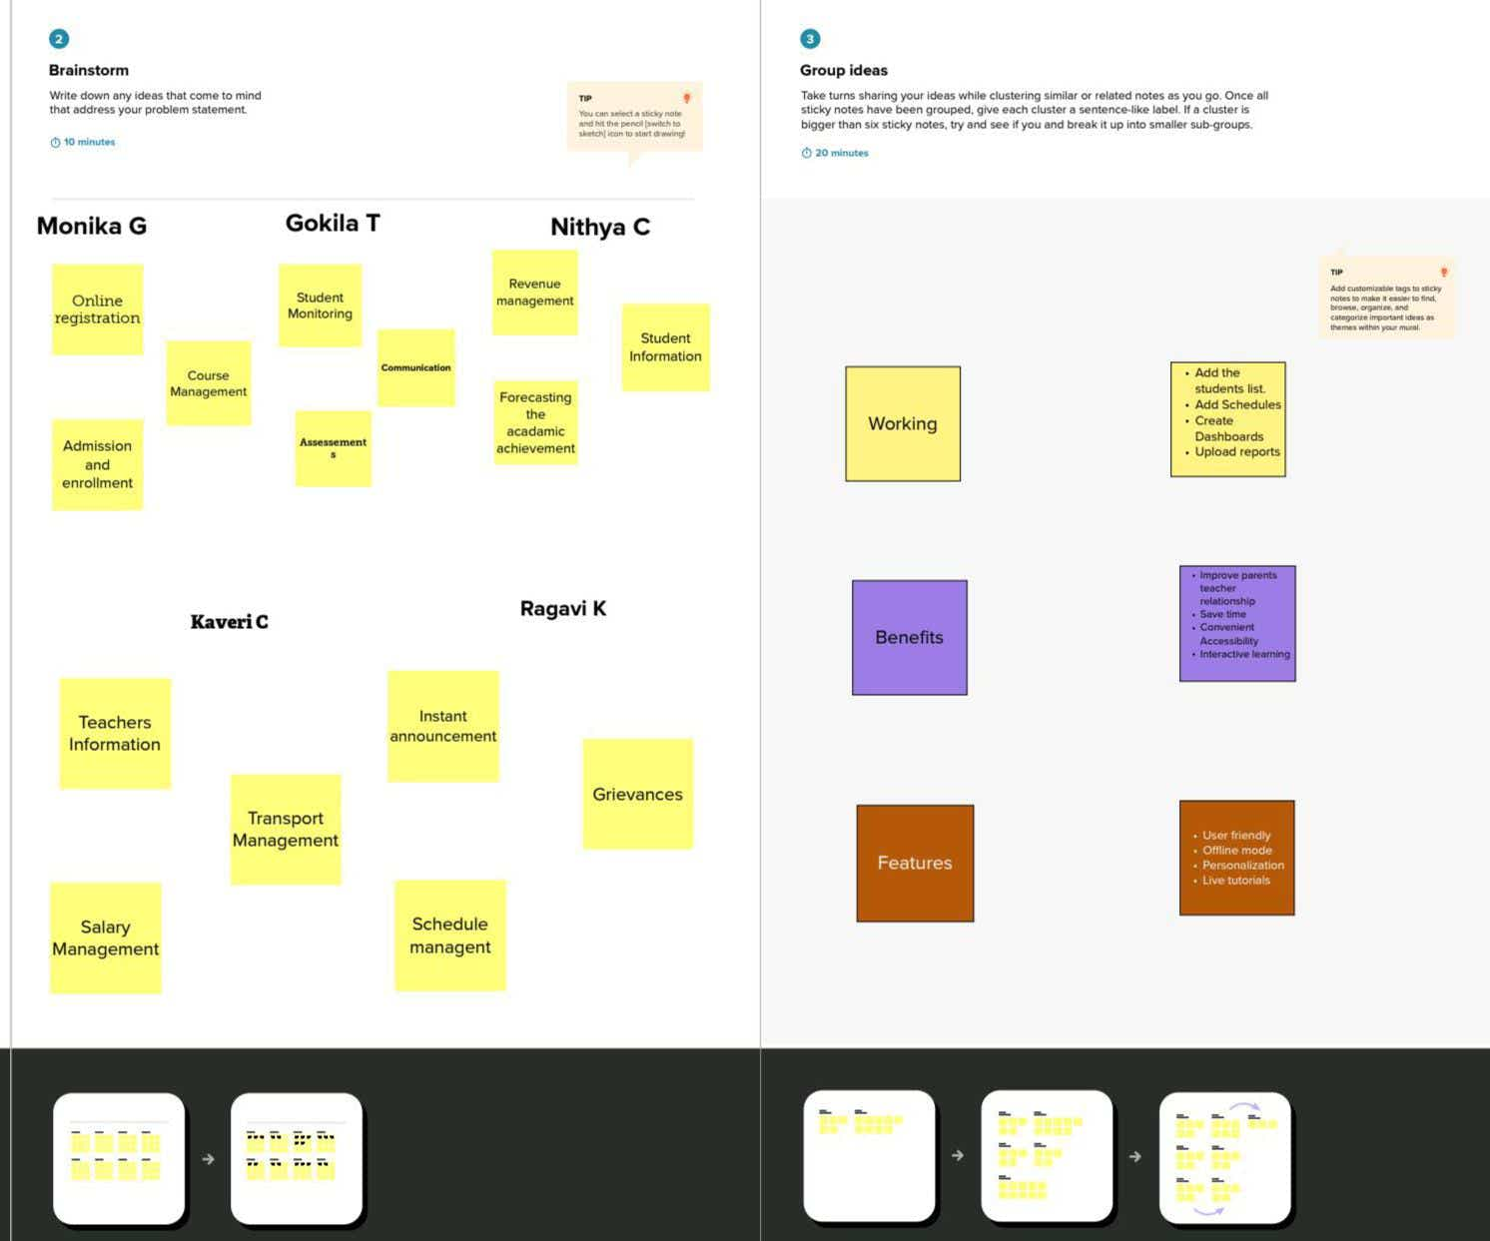

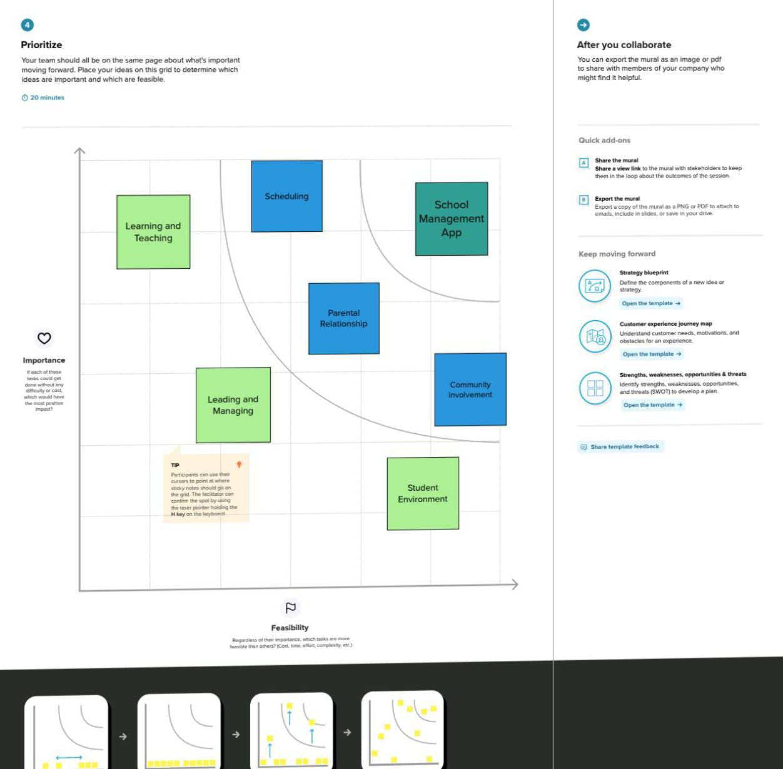

# RESULT

* 1. Data Model:

|  |  |
| --- | --- |
| **Object name** | **Fields in the Object** |
| Object 1  School | |  |  | | --- | --- | | Field label | Data type | | Address | Text Area | | District | Text Area | | State | Text Area | | School websites | Text Area | | Phone number | Phone | | Number of students | Roll up summary | | Highest Marks | Roll up summary | |
| Object 2  Student | |  |  | | --- | --- | | Field label | Data type | | Phone | Phone Number | | School | Master-Detail Relationship | | Results | Pick-list | | Class | Number field | | Marks | Number field | |
| Object 3  Parent | |  |  | | --- | --- | | Field label | Data type | | Parent Address | Text Area | | Parent Number | Phone | |

# Activity & Screenshot

Creation of Objects: Student, School, Parent

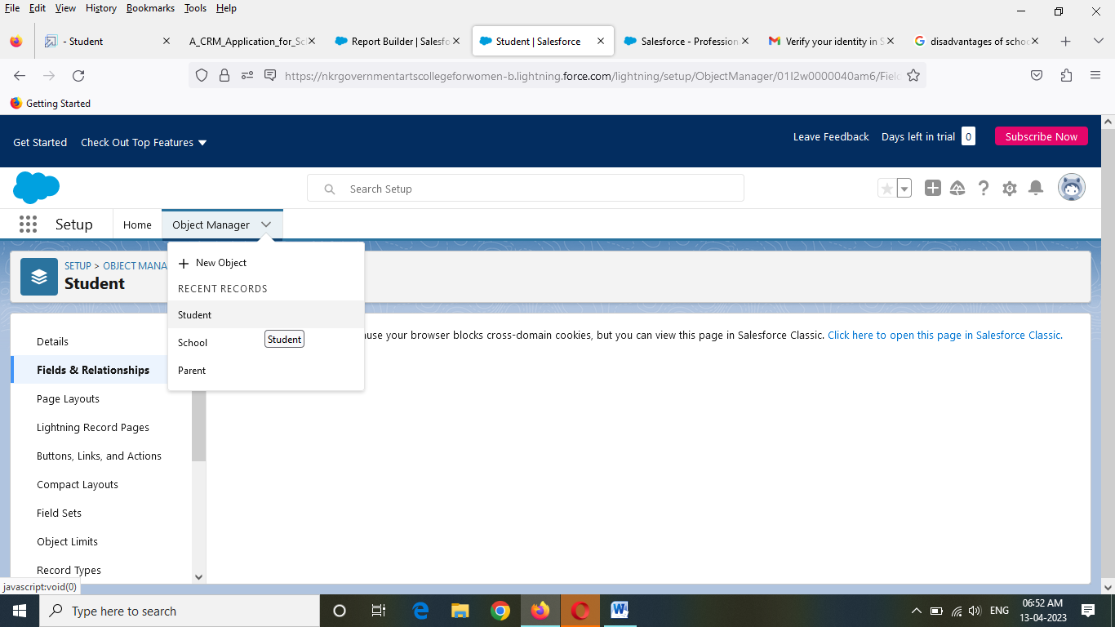

Creation of Lightning App: School Management

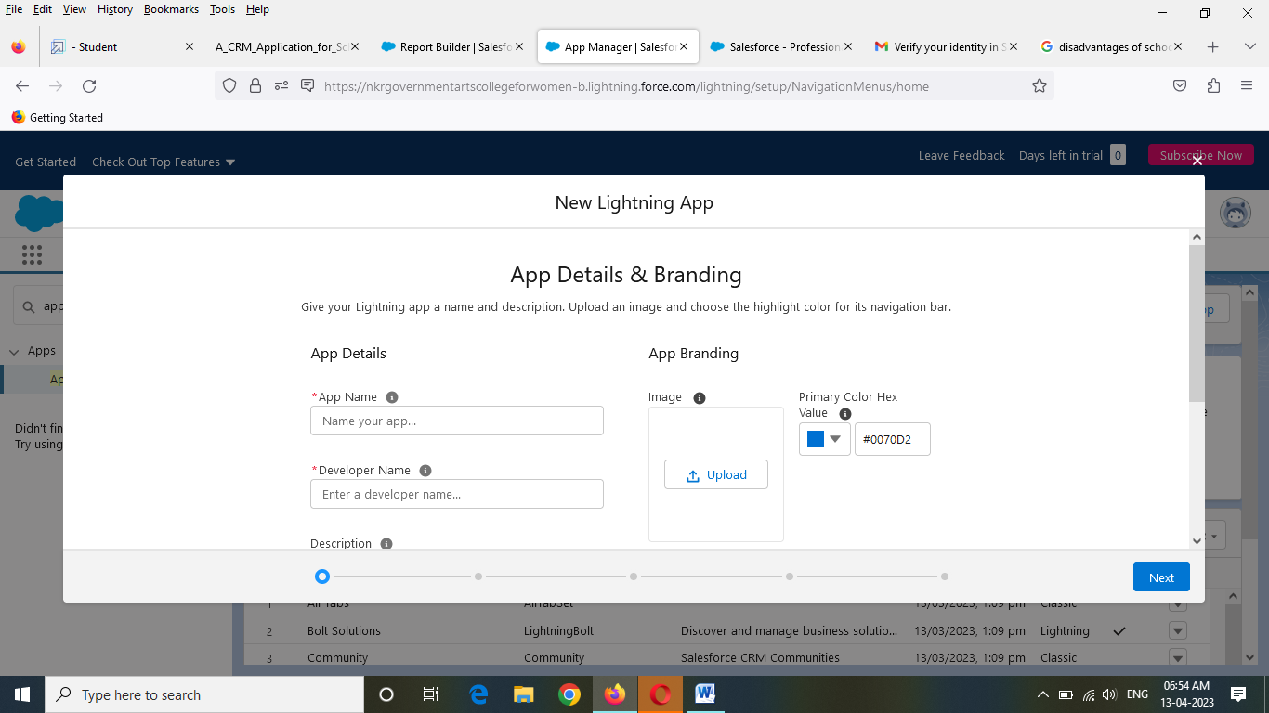

Field& Relationships

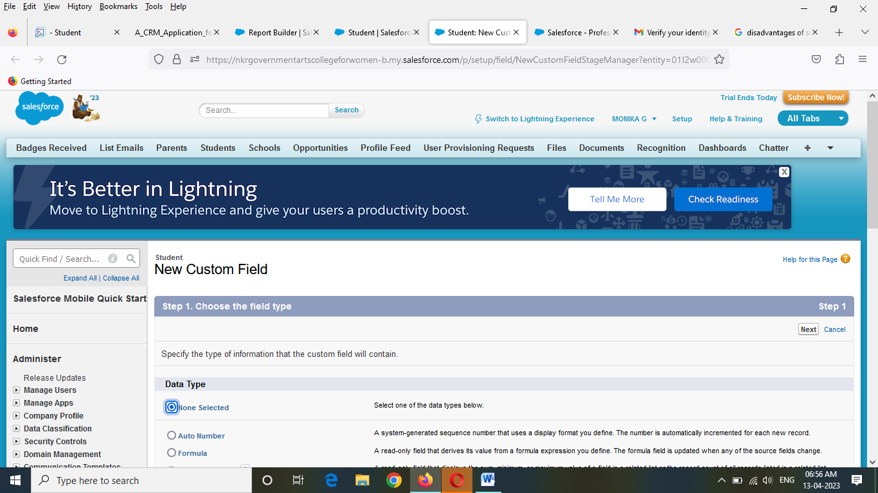

Profile

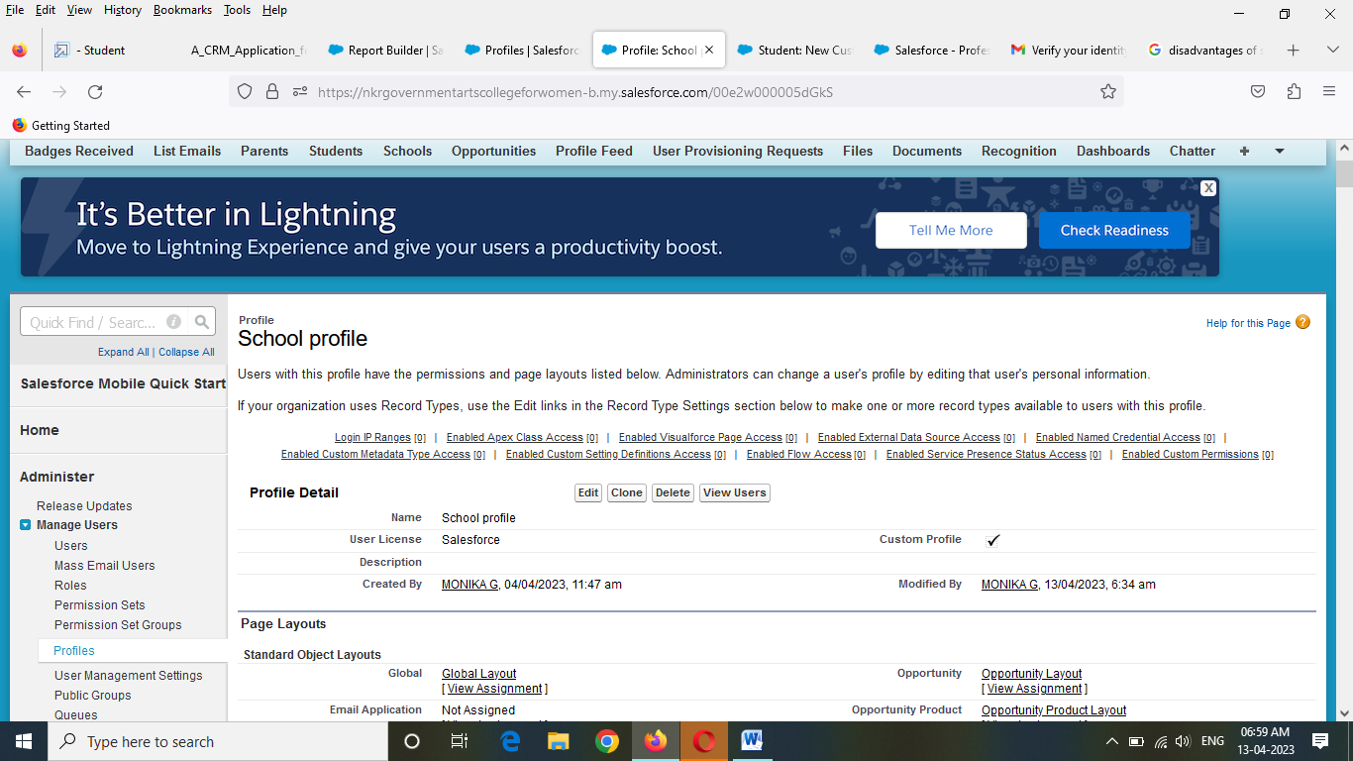

Users

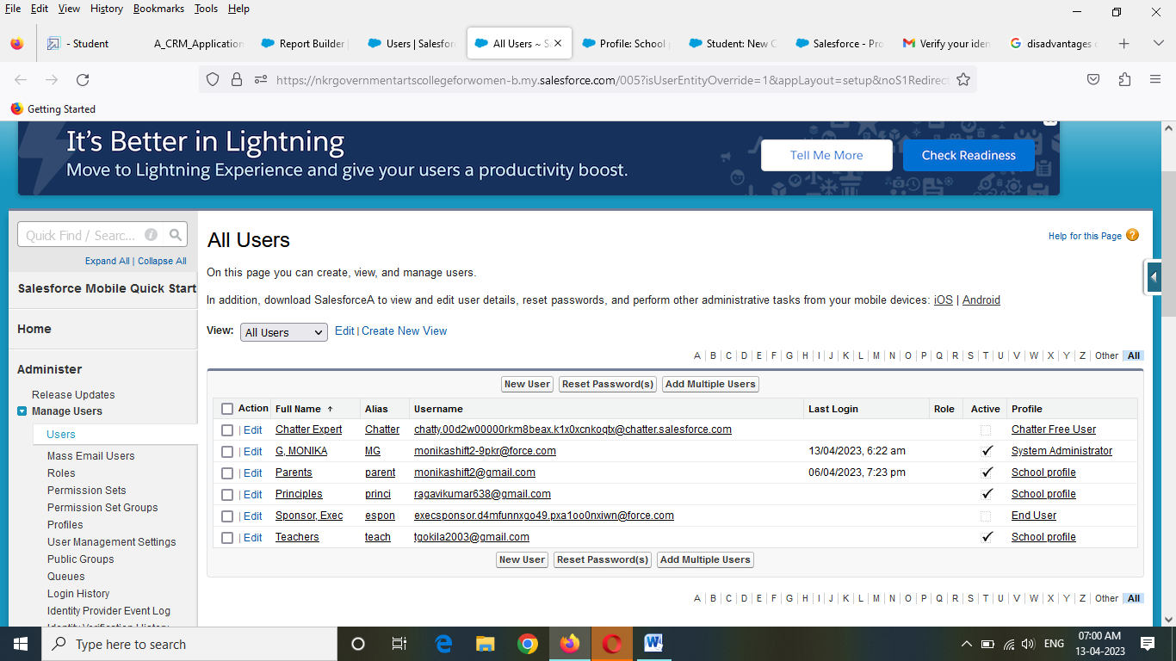

Permission sets

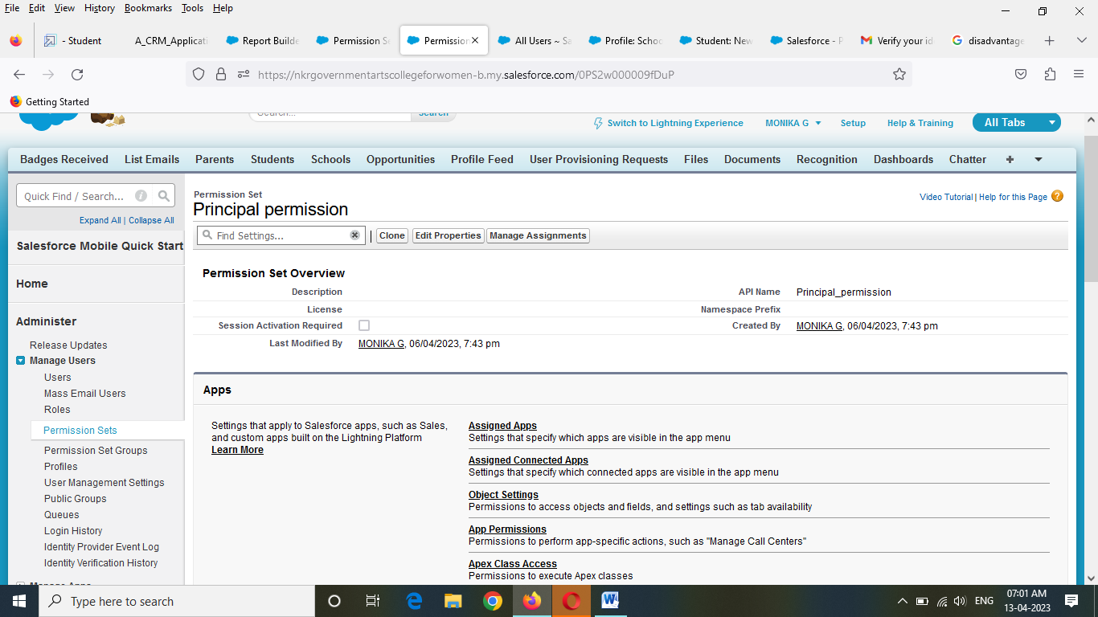

Reports

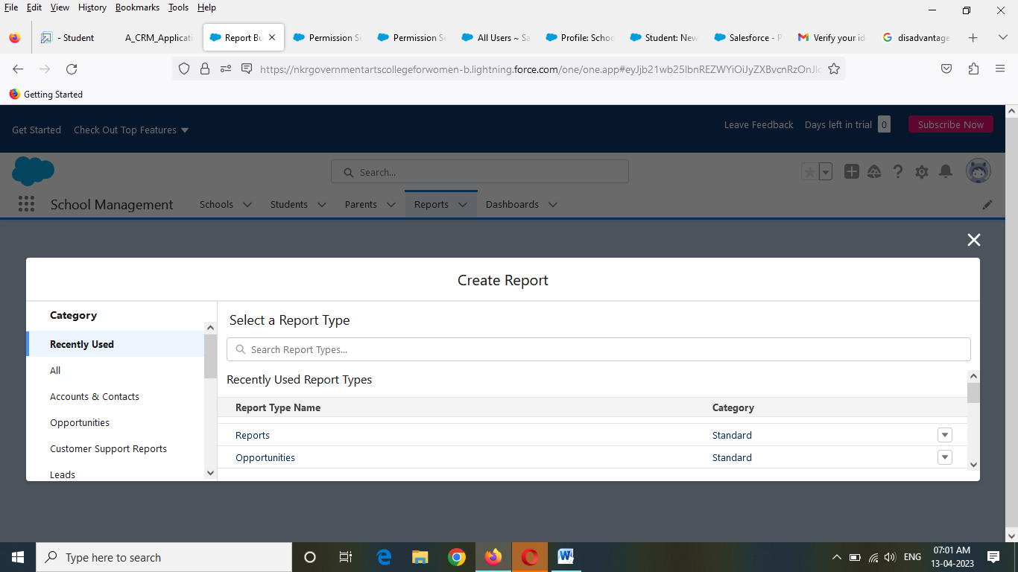

# Trailhead Profile Public URL

**Team Lead Monika G -**[**https://trailblazer.me/id/monig25**](https://trailblazer.me/id/monig25%20)

**Team Member 1 NITHYA C-** [**https://trailblazer.me/id/nithc4**](https://trailblazer.me/id/nithc4)

# Team Member 2 GOKILA T –

# <https://trailblazer.me/id/tgokila>

# Team Member 3 RAGAVI K – <https://trailblazer.me/id/ragak5>

# Team Member 4 KAVERI C- <https://trailblazer.me/id/ukaveric>

1. **ADVANTAGES**

Better Management of Student Data

Improves Overall Teacher Productivity

Provide Deeper Insights to Parents.

1. **DISADVANTAGE**

User-Interface. Complex-user interface may lead to increased difficulty in acceptance of the student management software among the school staff.

# APPLICATIONS

Schools

# CONCLUSION

This project is very useful for schools to maintain the student’s personal information and academic performance.

# FUTURE SCOPE

In future I want to add additional learning resources for students to improve their skills.